Some experiments demonstrating the necessity of low-level contents of conscious seeing

Andrew M. Haun¹ and Giulio Tononi¹

¹ Department of Psychiatry, University of Wisconsin, Madison, WI 53719, USA

Correspondence:
Andrew Haun: andrew.haun@wisc.edu
Giulio Tononi: gtononi@wisc.edu
Department of Psychiatry
University of Wisconsin-Madison
6001 Research Park Blvd, Madison, WI 53719 USA

- Introduction
We carried out two sets of experiments to test some intuitions about differences between what we are able to see, report, and remember. The intuitions can be summarized as follows: that we can report about only a very limited part of what we can see; and we can retain or remember only part of what we can report. Counter to these intuitions, it is sometimes argued that, perhaps, while we may believe we see more than we can report, in actuality report defines what we see – any notion to the contrary is dismissed as naïve or even delusional (or illusional).

- Experiments & Results
  - Memory for categorically constrained scenes
The first set of experiments take the form of a classic scene memory task (Konkle et al., 2010a; Standing, 1973). In such tasks, the observer attends to a long series of images. After this, sometimes days afterwards, the observer is tested to see how many of the images they recall. Recall performance in these studies is generally rather good, and some might be surprised at how much we can recall of a large set (as many as thousands) of briefly viewed photographs. However, results in these experiments can be taken to support the notion that we see much less than we think we do, since manipulations of the ‘study set’ of images can reveal that recall is based on relatively sparse categorical or ‘high level’ content (Konkle et al., 2010a, 2010b). It is clear that we do not remember images because we retain high-resolution copies of them in our memories; we remember them because of the distinctive – and relatively sparse – set of recognitional properties they present to us. Recall is much poorer when the study set is composed of similar kinds of scenes, than when the study set is drawn at random from all possible scene types.
We thought to push this reliance of recall on categorical distinctiveness to its extreme. We synthesized large numbers of natural-appearing images, all with the same descriptive text ‘prompt’, and used these in the standard memory paradigm (Figure 1A,B). Observers viewed 128 images in a ‘study’ phase, and afterwards they were tested in a 2AFC recall task where one of each pair of images was from the study set. Average hit rate over N observers was around 68% correct (Figure 2A). In a similarly-structured study where observers studied 2,912 images, and where each image was a member of a set of 64 categorically-similar images, hit rate averaged around 76% correct (Konkle et al., 2010b); in a condition where all images were ‘categorically novel’, average hit rate was around 96% correct (Konkle et al., 2010b). A hit rate of 68% should thus be interpreted as indicating inordinately poor recall.
During the study phase, observers perform an “N-back” task – they had to report when images repeated, either 1-back or 3-back (Figure 1A). In many memory studies the study-phase task is ostensibly to keep the observer’s attention on the images, and the fact that back-to-back performance is generally very good is usually not a primary piece of data. For our purposes it is of central interest: even though their recall for the synthesized images was very poor, observers were nevertheless very good at noticing when images repeated back-to-back – most observers (11 of 14) performed this task perfectly (Figure 2A).
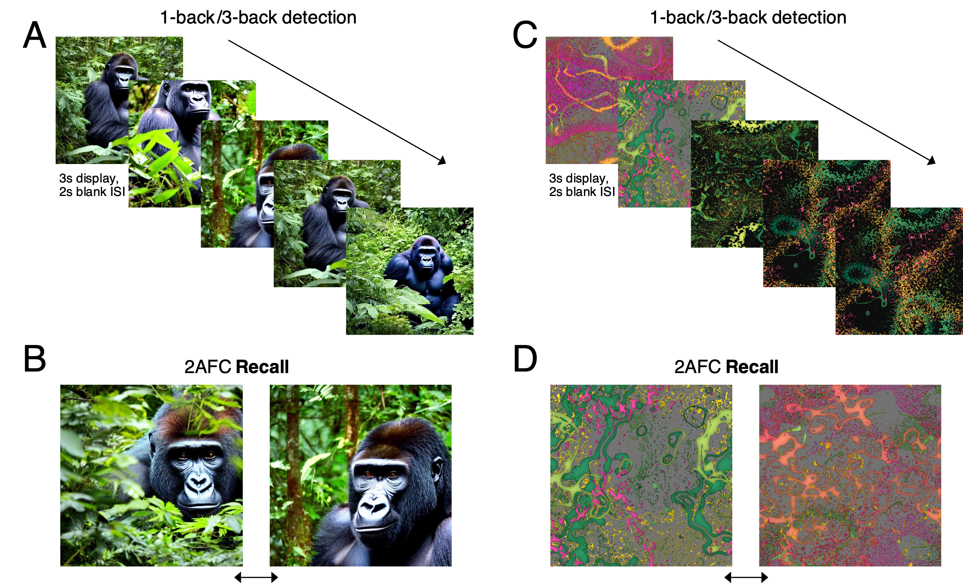
Figure 1. Memory task design, with example images from the Scene and Splatter conditions. In the study phase (A,C) the observer watched a sequence of images, each displayed for 3s followed by a 2s blank screen. The observer pressed the space bar if they thought they saw an image repeated (either 3-back as in A, or 1-back as in C). After 128 trials of this, the observer rested for a few minutes and then completed the 2AFC recall test (B,D), where on each trial two images were presented: the observer indicated which they thought they had seen before in the study phase.

As others have before us, we surmised that noticing back-to-back repeats can’t just be a matter of the same categorical representations that underlie recall performance. It must involve perception of the lower-level spatial structure of the images: observers can see when this structure is the same or different from one image to the next, and this is how they do so well in noticing repeats. If there is any skepticism about this interpretation – perhaps, some might argue, even in the short term the perceptual representation of a briefly-seen image is still largely categorical, top-down, or high-level (e.g. Ahissar & Hochstein, 2004) - we aimed to put it to rest with our next condition: we had subjects do the same memory task with a set of nonsense images, random ‘splatters’ of a type that no one could have seen before (Figure 1C). With these strange images, recall was even poorer than with the scenes (the main effect of image type on the data as presented in Figure 2C, F(1,100)=6.168, p=.0147) – many observers were just guessing when tested minutes later on their recall for the random splatters (Figure 2B). Yet, they were just as good at noticing the repeats: again, most observers (14 of 23) performed the 1-back task perfectly (Figure 2B).

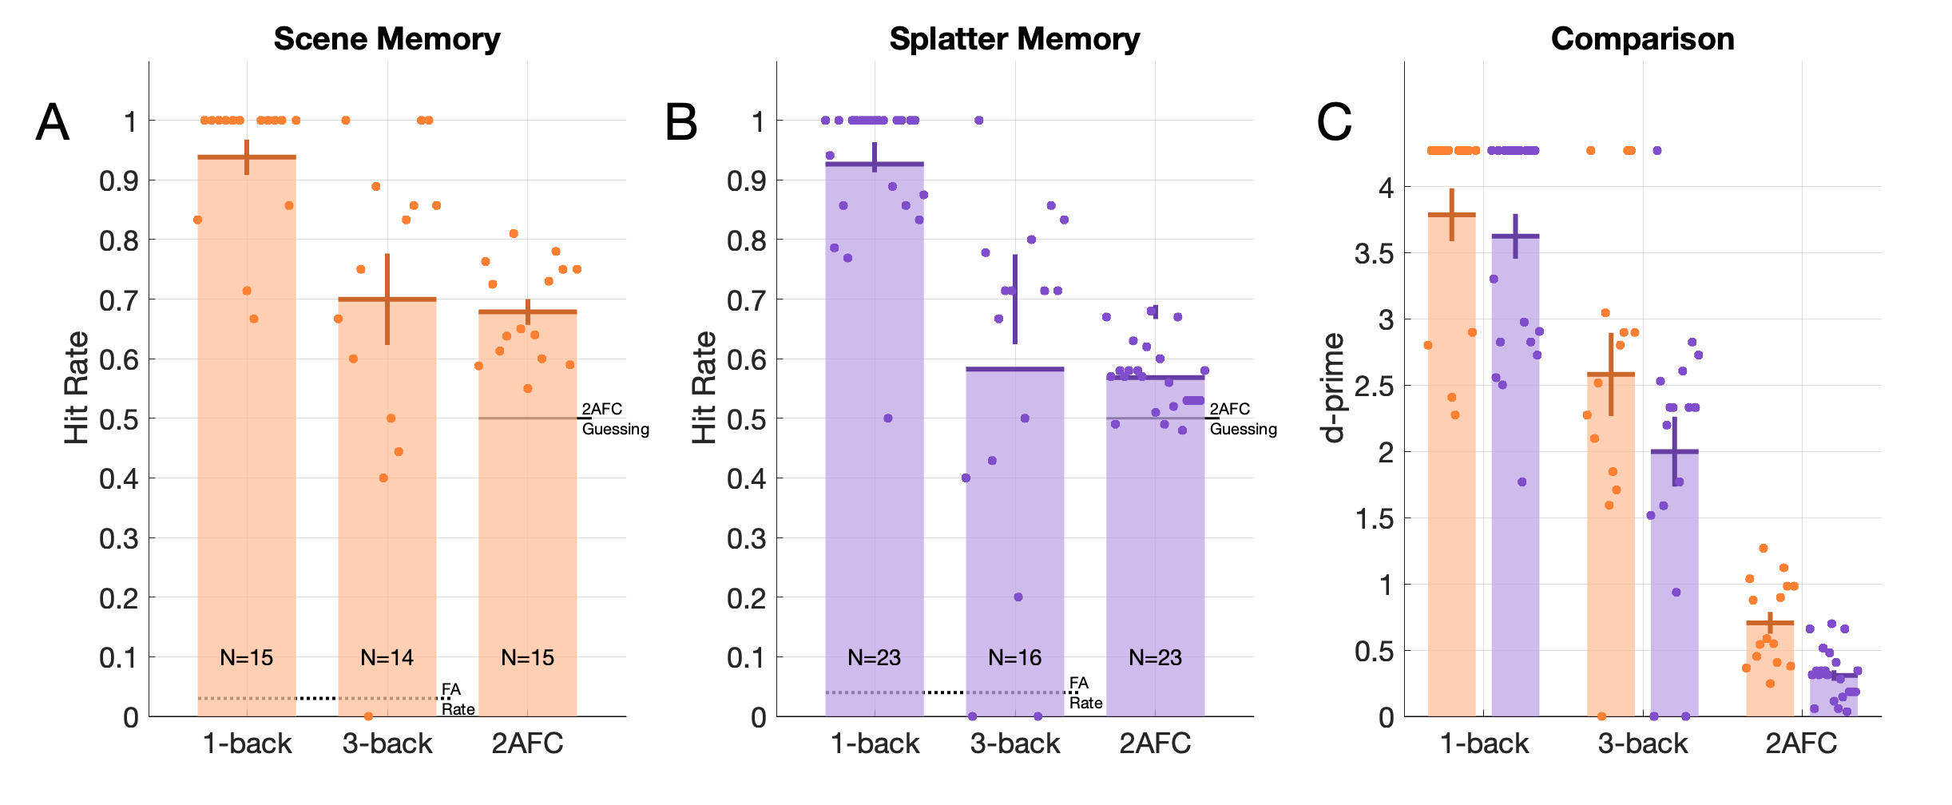
Figure 2. Memory task results. A) Recall of synthetic scenes. Dots are individual subjects, bars are group means (with SEM plotted). For the N-back tasks, the False Alarm rate is indicated by the black dotted line. For the 2AFC recall task, the 50% ‘guessing’ rate is indicated by a black line. Number of subjects in each condition is indicated by the ‘N=’ in each bar. B) Recall of ‘splatter’ images. C) Comparison of all conditions, all results in the form of signal-noise ratios (d-prime).

With the random splatter images, it seems much less plausible that the perceptual representation is entirely abstract or high-level. The images appear to be richly detailed, filled with dense, impossible-to-describe structure. But they don’t seem to elicit many high-level concepts or categories. Based on observers’ reports, some images were more memorable because a certain shape might look like a letter, or the outline of a familiar object. A few observers reported intentionally using a strategy like this (after completing the experiment, we had observers write down their thoughts about how they had carried out the tasks), and they were the ones with the best recall in the group. But for most images seen by most observers, words failed to suffice, and observers based their judgments on the spatial patterns of shapes and colors that they saw. For this reason, we suppose that memory performance cannot really be used to support the notion that seeing is mostly a matter of categories and high-level representations. The spatial stuff is there, and it is exceedingly rich, even if it cannot be described and even if it rapidly dissolves as images change over time (Becker et al., 2000; Lamme, 2010).

  - Perception of scattered dots
The second set of experiments were focused on perception of very simple stimuli: white dots on a black background. Although these stimuli are easy to define computationally, as a set of illuminated positions, they seem to easily exceed our capacities for perceptual reporting. If just a few dots are flashed on a display, an observer might be able to recall – and report – all of their positions with some accuracy. But for more than a handful – more than six or seven – observers have increasing difficulty with knowing how many dots there were (Burgess & Barlow, 1983; Kaufman et al., 1949; Taves, 1941), much less retaining their locations. This is the case just moments after a set of dots is shown (and taken away): beyond six or seven dots, we just cannot know how many there were without counting them, and we cannot recall the positions of more than a few of them.
This is the kind of fact about perception and reporting that could lead some to argue that, in fact, we don’t actually see all those dots. We just see a few of them, and beyond that we see a kind of vague “dottiness”, a statistical representation of “possible dots” (Cohen et al., 2016; Ward, 2018). This doesn’t seem to agree at all with what it’s like to see the dots, however – upon seeing a scattering of dozens of dots, most observers would insist that they do see many dots, more than they can count, but not that they see something vague and indeterminate. Here, to accommodate what it seems to be like to see the dots, some could try to finesse “report defines perception” somewhat, transforming it to “availability to report defines perception” (cite?). We sought to test this proposition with simple dot stimuli.

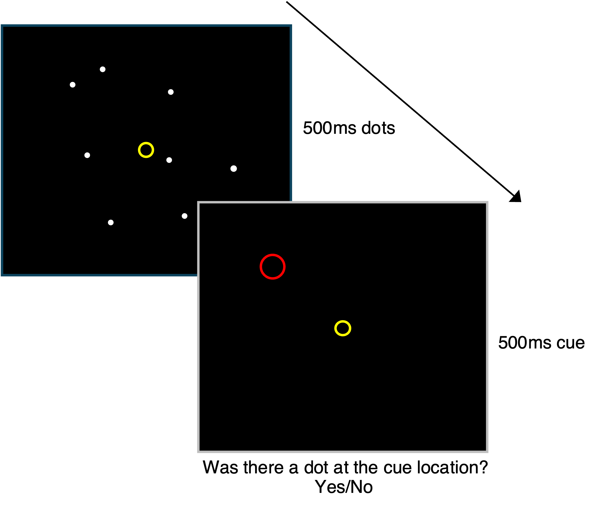
Figure 3. A partial-report task with dots. On each trial, a number of dots appear, randomly-scattered on the screen. The dots disappear after 500ms and a then a position cue (red circle) appears for 500ms. The subject responds Y/N to indicate if they think there had been a dot at the cued position.

We devised a novel ‘partial report’ paradigm for estimating the number of dots (or of dot positions) available to report after a glimpse of a random number of dots. Partial report tasks have been used to a similar purpose before. Sperling (Sperling, 1960) flashed an array of 12 (or 16) letters on the screen, and had observers try to report all the letters: typically observers would be able to report only a handful (5 or 6) of the letters correctly. However, he found that if he asked only for a partial report, by cueing one of the rows of 4 letters after the letters were taken away, observers could report all the letters in the row. He took this to mean that, immediately after the letters were taken away, observers still had all of them in memory, since they had seen them all. This memory trace decayed rapidly, too fast for all of the letters to be read out for report, but slow enough that any post-cued row could be prioritized by attention and read out before the memory was too decayed. Sperling’s paradigm has been used to argue that what we see isn’t just a matter of what we can report – it’s a matter of what we could report (Block, 2011; Phillips, 2011; Quilty-Dunn, 2020).
The task worked as follows. A number of randomly placed white dots, between 1 and 64, appeared briefly on a black screen and then disappeared. After they disappeared, a red circle appeared at some position (Figure 3). On half of the trials, the circle was at a position where there had just been a dot; on other trials, the circle was at a position where there had not been a dot. The observer’s task was to respond ‘yes’ or ‘no’, to indicate whether they thought there had just been a dot at the cued location. The data in the experiment reduce to the hit rate (HR) and the false alarm rate (FR) for each observer for each dot numerosity (N) they encountered (Figure 4). These values are converted to an estimate of accessible items by computing Cowan’s k (k_{c}), the product of dot number and the difference in HR and FR: N*(HR – FR) (Cowan, 2001; Rouder et al., 2011). Cowan’s k is plotted in Figure 4 for all observers, as a function of dot numerosity. There was plenty of between-observer variation in performance of the task, but on average it seems that ‘dots available to report’ is an extremely compressive, if not saturating, function of dot number: when 64 dots are presented, on average only around 8 seem to be available to report.

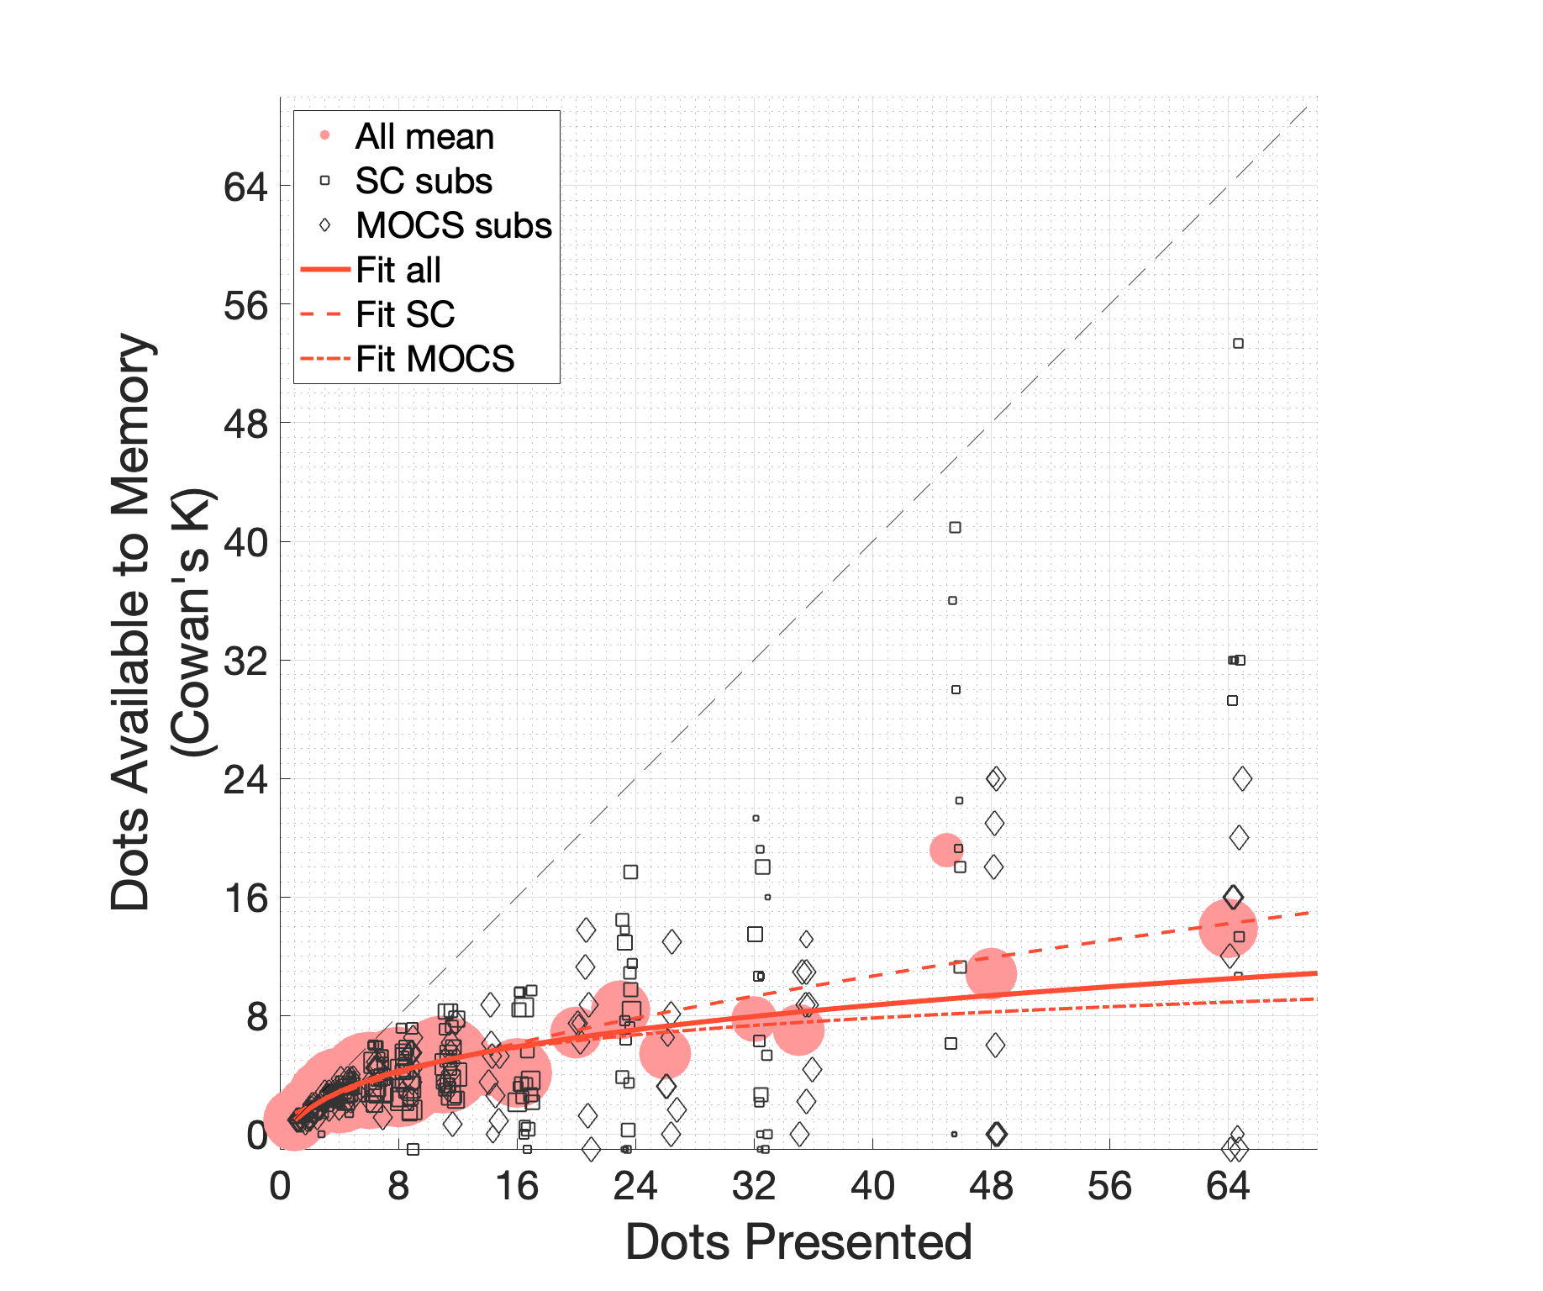
Figure 4. Average data (circles) and a model fits (red lines) for the partial report task. The scattered solid symbols represent performance of a single subject for a particular number of dots (with some horizontal scatter to make overlapping points distinguishable) – squares are SC subjects, diamonds are MOCS subjects (see methods). All symbols are scaled to the number of trials at that datum. The y-axis is the estimated number of dots available to memory and report: k_{c}, the product of the number of dots presented and the difference in hit rate and false alarm rate. For some data points (14 of 303 total), accuracy was negative - these data points are plotted along the lower axis of the plot at k_{c} =-1.

It seems that we see all the dots when dozens of them (or hundreds) are flashed on the screen. When we ask observers how many dots they saw on each trial (in a different experiment), subjects do report seeing many more than 8 dots, even if they are imprecise about the actual number (Figure 5A). If seeing is a matter of ‘availability to report’ (or availability to short-term memory, to be more precise), then observers should have had no trouble in the partial report task: even with dozens of dots, responses should have been very accurate, and Cowan’s k should be close to the number of presented dots. Yet according to the data, observers retained at most a handful of the dots – on average, Cowan’s k plateaus at fewer than ten. There are, essentially, two interpretations of this finding: either we do see the many dots in Figure 5B, and we just can’t retain more than a few of them for memory or reporting – or, we are subject to an illusion that is impossible to overcome, where we are constantly fooled as to the true nature of our experiences, which are vastly reduced in comparison to what we believe of them. That is: either we see all the dots, or we see eight of them.

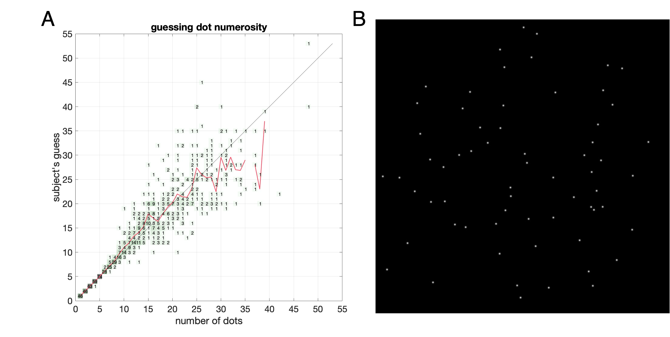
Figure 5. A) Subject reports (N=11) of how many dots they thought they saw (y-axis) after being shown a certain number (x-axis). The numbers in the plot represent the number of times a particular display/report pair occurred. For five or fewer dots, there was a single error in 289 trials (a presentation of ‘4’ dots was reported as ‘3’). For more than 5 dots, precision drops off precipitously, and for more than 10 dots an observer is more likely to guess incorrectly than correctly. Yet on average estimates are rather accurate, as shown by the red line (a weighted average of the guesses for each dot number). Subjects do not vastly underestimate the number of dots they see. B) A decent number of dots – you are unlikely to guess their number precisely, but do you see them all?

- Detailed Methods & Results
  - The memory task
We tested recall for two types of images: synthetic natural-appearing scenes, and synthetic random ‘splatter’ images. For both types of image, the experiment protocol was the same, except for some early subjects in the ‘splatter’ condition.

    - Protocol
The experiment consisted of two phases: the ‘study’ phase and the ‘test’ phase. Subjects were not told that there would be a test phase after the study phase, but they were always told that they should try to remember the study images for later recall.
During the study phase, a sequence of 128 images was presented one at a time against a gray background. Each image appeared for 2 seconds. Between images was a 1 second blank. Each image was unique unless it was a repeat of an earlier image. On a given trial there was a fixed 1 in 10 chance that an image would be scheduled for repeat; if an image was scheduled for repeat, subsequent images would not be eligible for repeat until after the image’s repeat had been presented. When it was determined that an image would repeat, it was randomly decided whether the repeat would be 1- or 3-trials later. So, the total number of repeats in a block of 128 trials was not fixed, and nor were the total number of either 1-back or 3-back repeats. Subjects were instructed to attend to the images as they appeared, and to try to remember them so they could notice if the images repeated. If the subject thought they saw a repeat of an earlier image, they were to press the space bar on the computer keyboard. The image sequence continued without pause, whether or not subjects made any response.
After the study phase, subjects were told that their recall of the images they just saw would be tested. On each trial of the test phase (of a total of 100 trials), which began after a short break (one or two minutes), two images were shown side-by-side on the screen and remained there until the subject responded. One of the images had been shown in the study phase, and one was new. The subject indicated, with the left/right arrow keys on the keyboard, which they thought they had seen before. The next trial began after subject response.

    - Subjects
A total of 31 unique subjects participated in the study, of whom 7 participated in both conditions. 23 subjects participated in the memory task with the ‘splatter’ images, and 15 subjects with the synthetic scenes. For the first 7 subjects in the splatter condition (one of whom also participated in the scene condition), there were only 1-back repeats in the study phase – the 3-back condition was added with the 8th subject. The number of subjects in each condition is indicated in Figure 2A. Subject ages ranged from 19 to 43. All subjects provided written informed consent to participate in the study.

    - Images
Images were presented on a digital display at a distance of 57 centimeters. All images in the study phase were square and 20 degrees across. The synthetic scenes were outputs from the Stable Diffusion algorithm (stability.ai, (Rombach et al., 2022)), using fixed prompts randomly selected from a list of human-generated scene descriptions from a database of natural scenes (Lin et al., 2014). Each observer saw images generated by a different random prompt, with the prefix “A color photo of ”, which ensured that all images had a similar format (otherwise images could have different styles – black and white, painting or drawing style, etc). Some examples are shown in Figure 6.
The ‘splatter’ images were produced by an algorithm devised for the purpose of this study, so that they would be a type that no subject had seen before. In essence, the algorithm (code is available at https://osf.io/krjtn/) consisted of successively layering the products of filtering, clipping, and coloring a sample of white noise. The splatter images were produced in batches each with a common color template and canvas (background) color; each subject saw splatters from a single batch. Some examples are shown in Figure 7. All images (scenes and splatters) were pre-generated before the experiment began.

Figure 6. Sample images from two conditions seen by subjects in the memory task. The prompt for the top-row images was: “A color photo of a person doing a flip in the air with skis on at night.” The prompt for the bottom-row images was: “A color photo of a tall giraffe looking over the tree tops as it forages”.

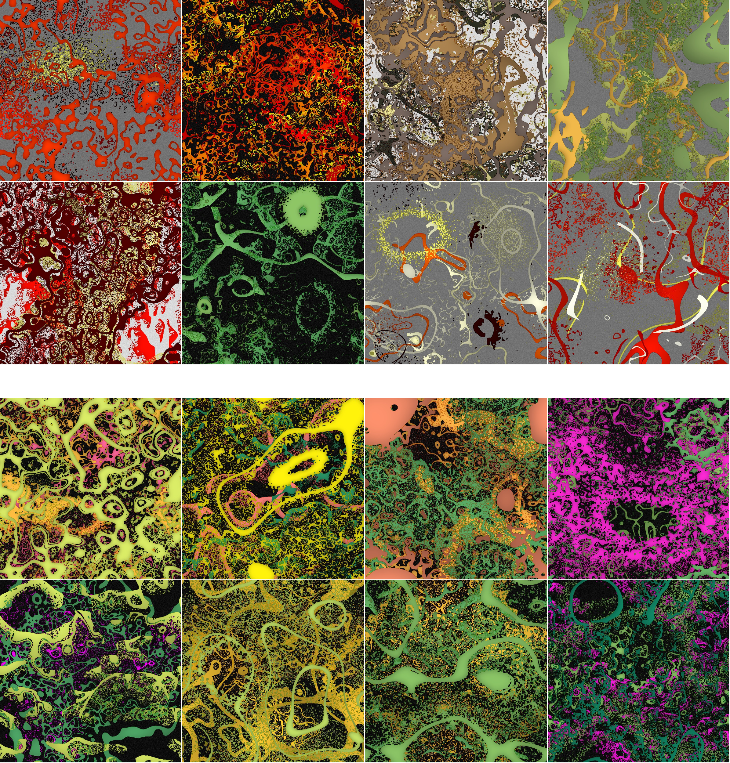
Figure 7. ‘Splatter’ images generated by filtering spatial noise. The top eight images are splatters drawn from different color batches. The bottom eight are splatters from the same color batch.

  - The dot partial report task
On this task we measured the number of dots (or dot positions) available to short-term memory (and to ‘report’). The task was modeled conceptually after the partial report task of Sperling (1960), who had subject view an array of letters, then a post-cue to indicate that observers should report a certain row of the array. In our task, subjects viewed an array of dots, and then a post-cue which indicated that the observer should report the presence or absence of a dot.

    - Partial report task protocol
On each trial of the partial-report task, a number of white dots flashed on a black screen simultaneously for 500ms, and upon their disappearance a cue (a red circle) appeared at some position within the region of the dot display, also for 500ms. On some trials (half), there had just been a dot within the region of the cue; on other trials there had been only darkness. The subject had to respond ‘yes’ or ‘no’ (with y/n keys on a keyboard) to indicate if they thought there had been a dot at the cued position. After response the next trial began immediately. A fixation marker was always present on the screen, and observers were instructed to continuously foveate it during the task.
The number of dots on each trial was determined by a 2-up 1-down staircase (SC) for 18 observers, and by method of constant stimuli (MOCS) for an additional 8 observers. For the SC condition, the first trial had a single dot. If a subject made two correct responses in a row, the next trial would have additional dots according to a pre-determined sequence (for most subjects the sequence was D={1,2,3,4,6,8,11,16,23,32,45,64,91,128}). For the MOCS condition, the number of dots was randomly chosen on each trial from the same pre-determined sequence, such that an equal number of trials (16 for each subject) were shown for each number. All SC observers did at least 2 blocks of 80 trials each (these were short experiments performed in the same visit with other tasks, including the memory task and others not reported here), while each MOCS observer did four blocks of 104 trials each. The sequence was an exponential function related to the display grid (see ‘dot positions’ below). The MOCS condition was added to address some concern that the SC procedure might have been ‘teaching’ some subjects to do the task in an unintended way. Based on conversations with some high-performing subjects – note the squares very close to the main diagonal at high dot counts, in Figure 4 – seeing many trials in a row with large numbers of dots was suggesting something to them about the geometry of the dots distribution (see Dot positions section below). However, the overall result between the two methods was not meaningfully different (Figure 4, dashed and dot-dashed lines, which overlay the full fit), so in the end we combined all results.

    - Subjects
26 subjects participated in the partial report experiment. One of these was the first author of this report. Subject ages ranged from 20 to 43. All subjects provided written informed consent to participate in the study.

    - Dot positions
We took some care to ensure that, while the dots were randomly placed for each stimulus, they would not fall too close to one another, since very nearby dots, especially peripherally-viewed, might not be psychophysically distinguishable. To accomplish this we defined an invisible grid of 140 XxX squares falling within a thick donut shape (Figure 8). The N dots on a given trial were randomly selected from these 140 possible positions, and each was randomly jittered to a position within a 1.9°x1.9° square centered on that starting position (Figure 8A).

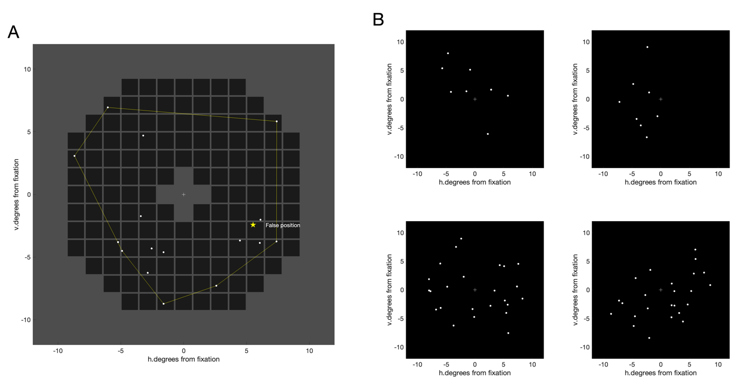
Figure 8. A) The dot-placement method. An invisible grid of 1.9° squares was defined, each 2.1° apart, within which a single dot could appear at a uniformly random position. Dots were not allowed to appear beyond 10° eccentricity, or within a square that would overlap the central 1° of the visual field. Here 16 randomly-placed dots are shown. Also illustrated is the method for determining the position of a ‘false cue’, which was restricted to fall within the convex hull of the set of dots displayed – so, the post-cue never indicated a position ‘outside’ the mass of displayed dots. B) Four examples of random dot patterns generated using this method – the underlying constraint on dot placement does not obviously influence the apparent ‘randomness’ of the dots.

    - Modeling Cowan’s k
The estimated available items appeared to follow a very compressive function of the number of items presented, so we applied a basic sigmoidal perceptual model, the Naka-Rushton or hyperbolic ratio function, which can potentially plateau at a fixed value, increase quasi-linearly from zero over a range of values, or some power function in-between:
$${\hat{k}}_{c}=a\frac{N^{c}}{b+N}$$

The model was not fitted directly to the subject k_{c} values. Instead it was fitted to the accuracy data, i.e. A=HR – FA or $\hat{A}=\frac{{\hat{k}}_{c}}{N}$ . This way a maximum likelihood estimator could be easily defined as:

$$E=\sum_{i}{\left(H_{i}*\hat{A_{i}}+M_{i}*\left(1-\hat{A_{i}}\right)\right)}$$

Where Â is the model accuracy for the i^{th} data point, H is the number of hits for that data point, and M is the number of misses. Each data point was the performance of a single subject for a specific number of dots. The model was fitted to the entire data set (all subjects), and also the SC and MOCS subject sets separately. All three are shown in Figure 4. In each case, the model tends to an extremely compressive function of dot number: for 64 dots, the data suggest that on average only eight or nine are available to memory and reporting.

  - The dot counting task
The dot counting task (Figure 5) used dot stimuli generated using the same method as the partial report task. A random number of dots appeared on the screen for 500ms, and then a ‘numpad’ appeared on the screen – subjects used the mouse to input their guess as to how many dots had appeared. The number of dots presented did not exceed 48 – we kept the numbers relatively low so that the task would feel more ‘doable’ to subjects (though, we found, it still did not feel that way!). Dot numbers were drawn from a two-step process – first an integer between 1 and 32 was uniformly drawn for each of 64 trials (7 subjects did a single block of the experiment; four did two blocks). Then a normally-distributed value with sd=8 was added to this integer and the sum was rounded. Finally, any resulting value less than 1 was set to a random integer between 1 and 5. The purpose of this convoluted process was to produce a uniform distribution of integers over most of the range of values (between 5 and 32), to over-represent ‘easily counted’ numbers from 1 to 5 (to keep subjects’ spirits high) and to leave a tail of rarer, higher than 32 values. All 11 of these subjects also participated in the SC condition of the partial-report task.
References
Ahissar, M., & Hochstein, S. (2004). The reverse hierarchy theory of visual perceptual learning. Trends in Cognitive Sciences, 8(10), 457–464.
Becker, M. W., Pashler, H., & Anstis, S. M. (2000). The Role of Iconic Memory in Change-Detection Tasks. Perception, 29(3), 273–286. https://doi.org/10.1068/p3035
Block, N. (2011). Perceptual consciousness overflows cognitive access. Trends in Cognitive Sciences, 15(12), 567–575.
Burgess, A., & Barlow, H. B. (1983). The precision of numerosity discrimination in arrays of random dots. Vision Research, 23(8), 811–820. https://doi.org/10.1016/0042-6989(83)90204-3
Cohen, M. A., Dennett, D. C., & Kanwisher, N. (2016). What is the Bandwidth of Perceptual Experience? Trends in Cognitive Sciences, 20(5), 324–335. https://doi.org/10.1016/j.tics.2016.03.006
Cowan, N. (2001). The magical number 4 in short-term memory: A reconsideration of mental storage capacity. Behavioral and Brain Sciences, 24(1), 87–114.
Kaufman, E. L., Lord, M. W., Reese, T. W., & Volkmann, J. (1949). The discrimination of visual number. The American Journal of Psychology, 62(4), 498–525.
Konkle, T., Brady, T. F., Alvarez, G. A., & Oliva, A. (2010a). Conceptual distinctiveness supports detailed visual long-term memory for real-world objects. Journal of Experimental Psychology: General, 139(3), 558.
Konkle, T., Brady, T. F., Alvarez, G. A., & Oliva, A. (2010b). Scene Memory Is More Detailed Than You Think: The Role of Categories in Visual Long-Term Memory. Psychological Science, 21(11), 1551–1556. https://doi.org/10.1177/0956797610385359
Lamme, V. A. (2010). How neuroscience will change our view on consciousness. Cognitive Neuroscience, 1(3), 204–220.
Lin, T.-Y., Maire, M., Belongie, S., Hays, J., Perona, P., Ramanan, D., Dollár, P., & Zitnick, C. L. (2014). Microsoft coco: Common objects in context. Computer Vision–ECCV 2014: 13th European Conference, Zurich, Switzerland, September 6-12, 2014, Proceedings, Part V 13, 740–755.
Phillips, I. B. (2011). Perception and iconic memory: What Sperling doesn’t show. Mind & Language, 26(4), 381–411.
Quilty-Dunn, J. (2020). Is iconic memory iconic? Philosophy and Phenomenological Research, 101(3), 660–682.
Rombach, R., Blattmann, A., Lorenz, D., Esser, P., & Ommer, B. (2022). High-Resolution Image Synthesis with Latent Diffusion Models (arXiv:2112.10752). arXiv. https://doi.org/10.48550/arXiv.2112.10752
Rouder, J. N., Morey, R. D., Morey, C. C., & Cowan, N. (2011). How to measure working memory capacity in the change detection paradigm. Psychonomic Bulletin & Review, 18(2), 324–330. https://doi.org/10.3758/s13423-011-0055-3
Sperling, G. (1960). The information available in brief visual presentations. Psychological Monographs: General and Applied, 74(11), 1–29.
Standing, L. (1973). Learning 10000 pictures. Quarterly Journal of Experimental Psychology, 25(2), 207–222. https://doi.org/10.1080/14640747308400340
Taves, E. H. (1941). Two mechanisms for the perception of visual numerousness. Archives of Psychology (Columbia University).
Ward, E. J. (2018). Downgraded phenomenology: How conscious overflow lost its richness. Philosophical Transactions of the Royal Society B: Biological Sciences, 373(1755), 20170355.

